**Faculty** = Miss Aatika Liaquat,

**Batch code** = 1804B2

**Curriculum**= 6673,

**Semester**= DISM,



APTECH | North NAZIMABAD

http://www.aptechnn.com

Muhammad Mesum Raza Rizvi (Student1103523), Mehwish Tariq (Student 1114548), Muhammad Sameer (Student1100106), Muhammad Affan Khan (Student1088697)

Event Management system

TAPLE OF CONTENTS:

Contents

TAPLE OF CONTENTS: 1

Acknowledgment 2

Abstract 3

declaration 3

Certificate 4

Chapter no 1: introduction 5

Objective 5

Problem Statement 5

motivaton 7

Need of project 8

CHAPTER NO 2 : PROJECT MAKING & BACKGROUND 9

Project duration 9

Task sheet 9

CHAPTER NO 3: SOFTWARE & HARDWARE REQUIREMENTS 11

Hardware Requirements: 11

Software Requirements: 11

CHAPTER NO 4: WORKFLOW 12

Submission Checklist 12

APPLICATION MAP 13

SCREENSHOT 14

CHAPTER NO 5: CONCLUSION 15

REMARKS 15

APPLICATION 15

PROBLEMS FACED 15

FUTURE ENHANCEMENT 15

## **Acknowledgment**

We would want to appreciate and thank all of those people who helped us during this journey of completing our project. Without everyone’s support, we could not have accomplished our work.

We express our sincere gratitude to our faculty “--Miss Aatika Liaquat--" and our coordinator for their amazing support and guidance, continuous encouragement and supervision throughout the course of the present work. It’s of no doubt that we have been very fortunate to work under such a supportive and cooperative teacher/coordinator

And last but not the least we are extremely grateful to the whole faculty and administration of Aptech, for providing us all the facilities that were mandatory, without which this project could not be a success.

***Signature:***

1. **Muhammad Mesum Raza Rizvi,**
2. **Mehwish Tariq,**
3. **Muhammad Sameer,**
4. **Muhmmad Affan Khan,**

**m**

## **Abstract**

The topic of our project was to develop an Event Management System

It’s made using C# WinForms and MySql Database Mainly.

## **Declaration**

We are writing this to declare that all the work which is being written bellow in this Project Report entitled “—EVENT MANAGEMENT SYSTEM--” is a veritable record of our own work submitted to the Aptech NN, Karachi, Pakistan during the year 2019 to 2020 in the partial fulfillment of semester ii (DISM) project We also declare that we have not submitted the material being presented in this Project Report for the award of any other degree elsewhere.

***Signature:***

1. **Muhammad Mesum Raza Rizvi,**
2. **Mehwish Tariq,**
3. **Muhammad Sameer,**
4. **Muhmmad Affan Khan,**

## **Certificate**

This is to certify that,

Mr.

**Muhammad Mesum Raza Rizvi Student1103523**

**Mehwish Tariq Student1114548**

**Muhammad Sameer Student1100106**

**Muhammad Affan Khan Student1088697**

Has successfully Designed & Developed

**EVENT BANK MANAGEMENT SYSTEM**

Date of Issue:

**18th-APRIL-2019**

Date of Submission:

**18th-MAY-2019**

Authorized Signature: **Ms. Aatika Liaquat**

# Chapter no 1: introduction

## Objective

### Problem Statement

#### **EVENT MANAGEMENT SYSTEM**

Event management system is used to manage all the activity related to event. In any event many service providers work simultaneously and it is very hard to manage these providers. It is also important for event organizer that he has all the contacts details of these service providers so that he can contact them any time to plan an event at given time. To manage all these activity we have developed this software.  To get success in the event management business, user should have strong network contacts of service provider. These contacts are essentially providers of specific services who can be mobilized quickly to participate in any given event. To make an event successful event manager needs different service provider like Sound systems services, Lighting providers, Canteen services, stage construction and so on. In present system Event Company has to do all management work manually. They keep all payment information on papers. There is no system to check the past expenses on any event. To do this they have to check payment register and this task is very time consuming and tiresome. Keeping this entire problem in mind we have developed this system. This system helps the event management company to manage their paper work in software and they can also retrieve report of last event they have completed.

**Functional Requirement:**

Following are the main module in this system.

1. **Customer Module** – It is customer who has to take initiative for inputting the values for any event.
2. **Event management** – The events needs to be entered for the company to organize.
3. **Service Providers management** – These are care taker of the event so work has to be allotted (like catering, decorations)

**1. Admin Login Form**

* Name
* Password
* Login Button

## Need of project

* Some of the benefits of Project are as under: -
* 1. Re-enforcement of Skills happens in the experiential learning process.
* 2. A mentor, ensuring that you do not get drifted, constantly guides you.
* 3. It gives you a lot of confidence to face an interview as you have worked on a project. You can explain virtually everything on the subject you have learnt.
* 4. A nice, final, black, hardbound report adds to you credentials and enhances your job prospects.
* Projects is compulsory (Sem-End Project) and is supposed to be done over and above the assignments given in your course books.
* It is advised that if a student follows the projects and submits Assignments, he would definitely have an edge over other students.
* Students need to submit their project report along with working application and source code in the stipulated time.

# CHAPTER NO 2 : PROJECT MAKING & BACKGROUND

## 

## **Project duration**

1. Analysis- 5 days
2. Design – 15 days
3. Development –18 days
4. Testing – 10 days
5. Documentation -8 days.

|  |  |  |  |  |
| --- | --- | --- | --- | --- |
| Analysis | Design | Database | Testing | Documentation |

|  |  |  |  |  |  |  |  |  |  |  |  |  |  |  |  |  |  |  |  |  |  |  |  |  |  |  |  |  |  |
| --- | --- | --- | --- | --- | --- | --- | --- | --- | --- | --- | --- | --- | --- | --- | --- | --- | --- | --- | --- | --- | --- | --- | --- | --- | --- | --- | --- | --- | --- |
| 1 | 2 | 3 | 4 | 5 | 6 | 7 | 8 | 9 | 10 | 11 | 12 | 13 | 14 | 15 | 16 | 17 | 18 | 19 | 20 | 21 | 22 | 23 | 24 | 25 | 26 | 27 | 28 | 29 | 30 |

## **Task sheet**

|  |  |  |  |  |  |
| --- | --- | --- | --- | --- | --- |
| **No.** | **Task** | **Actual Start Date** | **Actual Days** | **Team Mate Name** | **Status** |
| 1. | Case Study | 20th April 2019 | 2 | Muhammad Sameer | Completed |
| 2. | UI Designing | 28th April 2019 | 8 | Muhammad Affan Khan | Completed |
| 3. | SCENIRO Making | 5th May 2019 | 7 | Muhammad Affan Khan,  Mehwish Tariq | Completed |
| 4. | Material Searching | 9th May 2019 | 4 | Muhammad Mesum Raza Rizvi | Completed |
| 5. | Database Connectivity | 13th April 2019 | 4 | Mehwish Tariq | Completed |
| 6. | Documentation | 17th April 2019 | 4 | Muhammad Mesum Raza Rizvi | Completed |

# CHAPTER NO 3: SOFTWARE & HARDWARE REQUIREMENTS

## **Hardware Requirements:**

1. A minimum computer system that will help you access all the tools in the courses is a Pentium 166 or better.
2. 64 Megabytes of RAM or better

## **Software Requirements:**

1. Visual Studio 2013
2. Adobe Photoshop
3. Browser googles

# CHAPTER NO 4: WORKFLOW

## 

## **Submission Checklist**

|  |  |  |  |
| --- | --- | --- | --- |
| **S.NO** | **LIST OF ITEMS** | **Remarks** | **COMMENTS** |
| 1. | Do All Pages Linked together | **Yes** |  |
| 2. | Database Connected | **Yes** | Using  MDF FILE |
| 3. | Page Colors As Per Common Guidelines | **Yes** |  |
| 4. | All SQL Queries Working | **Yes** |  |
| 5. | DOCUMENTATION Included | **Yes** |  |
| 6. | Project Zip File | **Yes** | Created using WinRAR |

## **APPLICATION MAP**

**BBMS**

ADMIN

MODULES

ADD SOUND SYSTEM

ADD STAGE DECORATION

ADD CATERING

ADD VENUE

BOOK EVENT

PAYMENT

STAGE DECORATION

SOUND SYSTEM

CATRING

VENUE

SERVICE MODULE

EVENT MODULE

COSTUMAR MODULE

## **SCREENSHOT**

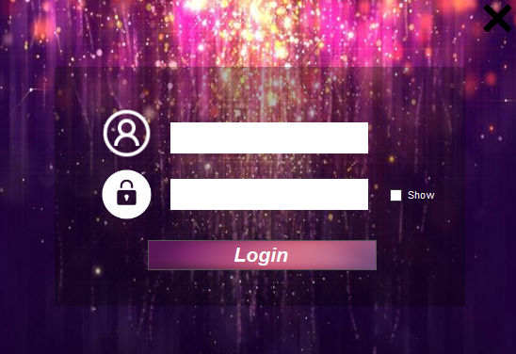

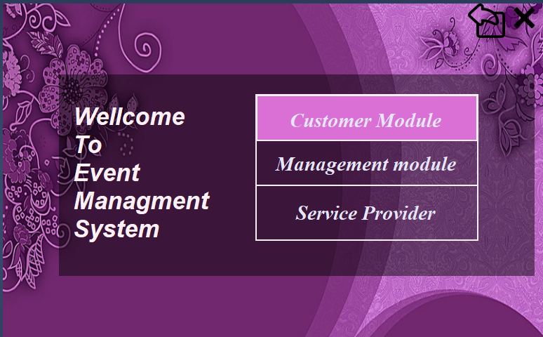

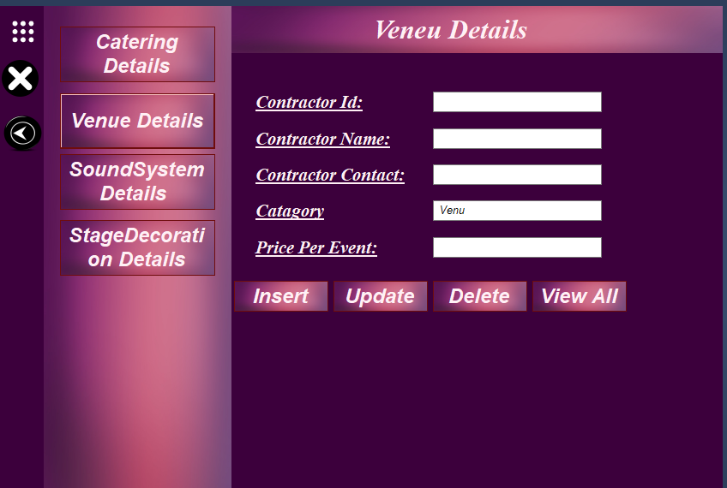

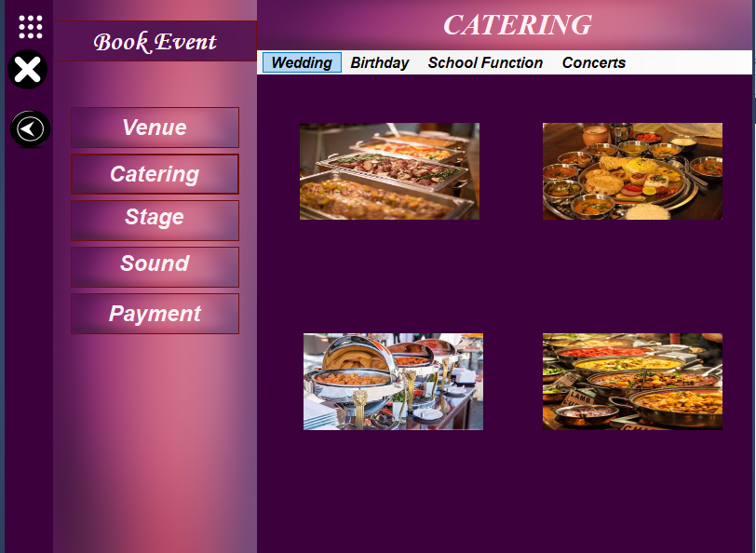

# CHAPTER NO 5: CONCLUSION

## **REMARKS**

IT IS VERY NICE INITITATIVE THAT HAS MADE US WORK HARDER ON OUR PROJECT AND IT HAS POLISHED OUR SKIILLS NOW WE ARE CAPABLE OF MAKING A DESKTOP APPLICATION ALL BY OUR OWN SELF.

## **APPLICATION**

ITS BLOOD BANK MANAGEMENT SYSTEM IT CAN BE USED WIDELY IN HOSPITALS AND LABATORIES IT IS VERY USEFULL FOR THE HOSPITAL STAFF THAT FACE A LOT OF PROBLEMS IN BLOOD TRANSFUSION, TRANSFERENCE, BLOOD COLLECTION, BLOOD SCREENING, PROCESSING AND STORAGE.

## **PROBLEMS FACED**

DURING THIS COURSE OF PROJECT, WE HAD TO FACE ALOT OF PROBLEMS LIKE OUR GROUP MEMBER’S LEFT THE COURSE IN THE BEGINNING AND WE WERE ONLY TWO MEMBER PLUS VERSION ISSUES OF VISUAL STUDIO HAUNTED US A BIG TIME OVERALL IT WAS A GREAT EXPERIENCE.

## **FUTURE ENHANCEMENT**

IT IS ALMOST A PERFECT PROTO TYPE OF BLOOD BANK MANAGEMENT SYSTEM THIS APPLICATION CAN BE DIPLOYED AND USED IN REAL WOLRD!